Lab Exercise 7- Install Minikube on Linux (Ubuntu /MacOS/Windows)

Install Minikube on macOS

brew install minikube

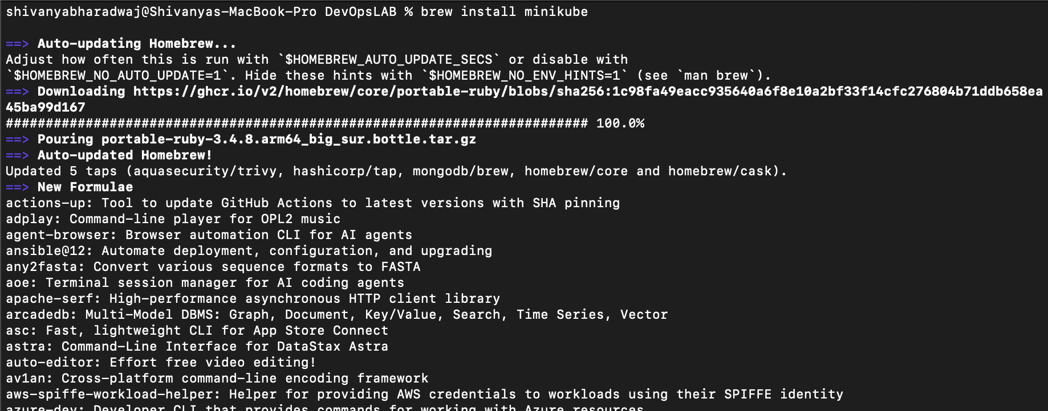
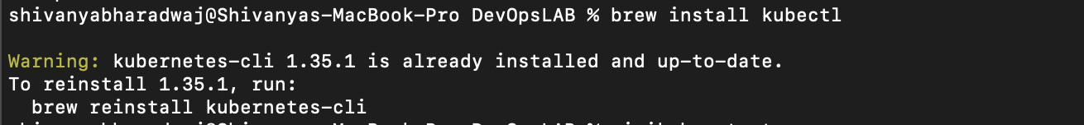
brew install kubectl

Start:

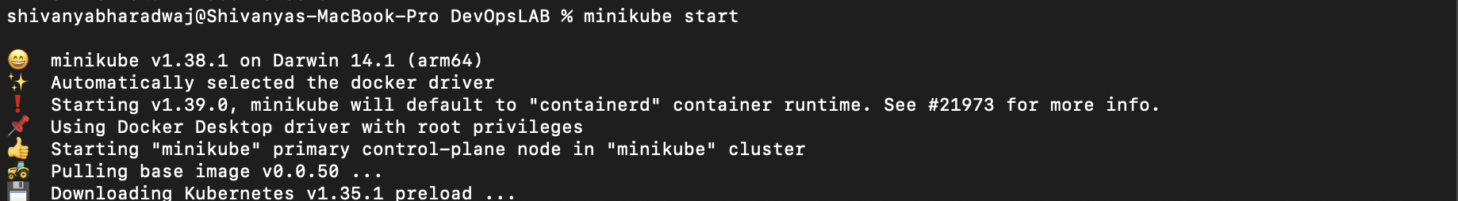
minikube start

Verify Kubernetes Cluster

kubectl get nodes

Expected output:

NAME STATUS ROLES AGE VERSION

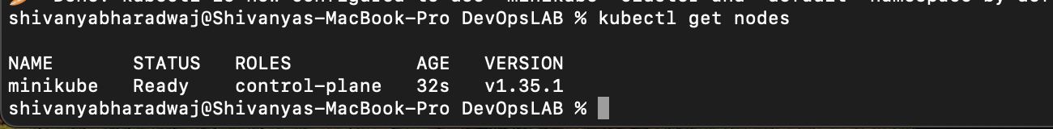
minikube Ready control-plane xx v1.xx

Useful Minikube Commands (Lab Ready)
Command | Purpose
minikube dashboard | Open K8s UI
minikube stop | Stop cluster
minikube delete | Delete cluster
minikube ssh | Access node
kubectl get pods -A | View all pods

